Programme: Horizon 2020

Project: METICOS

Project Duration: 1/09/2019-31/08/2022 (36 months)

Overall Budget: €4.997.481,25

METICOS Project (H2020) started in September 2020 aiming to introduce Big Data Analysis of border control information systems, in order to provide a step-change towards more modern and efficient Smart Border management and towards gaining societal and political acceptance of modern control technologies of EU borders such as “no-gate solutions”.
METICOS project will develop a platform able to integrate information systems and networks of sensors in order to validate the efficiency and users’ acceptance of these Smart Border technologies empowering three major sub-divisions of the wider border control sector.

METICOS was presented at the Nicosia Risk Forum, organized on the 26th of November 2020. Nicosia Risk Forum is an innovative event for the area of South-Eastern Europe, which brings together academic, industrial, governmental, policy, and other societal stakeholders with a significant interest in societal safety. METICOS Project Coordinator Mr. Pantelis Velanas presented the project and its objectives.

METICOS takes the initiative to create a synergy/community with other EU-funded projects and initiatives in order to exchange methodologies, practices, services, and knowledge created.
Our Goals:
- Identify common problems.
- Discuss on methodologies that each project prepares.
- Establish a joint task force for integrating the knowledge generated from each project.
- Exchange ideas about future policy suggestions.
- Support each other in terms of communication and dissemination.

Police Partners in the Project:
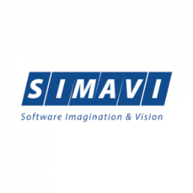
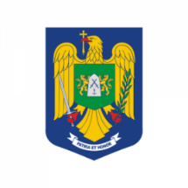

Head of the Head:

The project receives funding from
the Horizon Programme 2020 Research
and Innovation of EU (Agreement No. GA883075)

